🌩️ Amazon RDS (Relational Database Service) – Complete & Easy Explanation
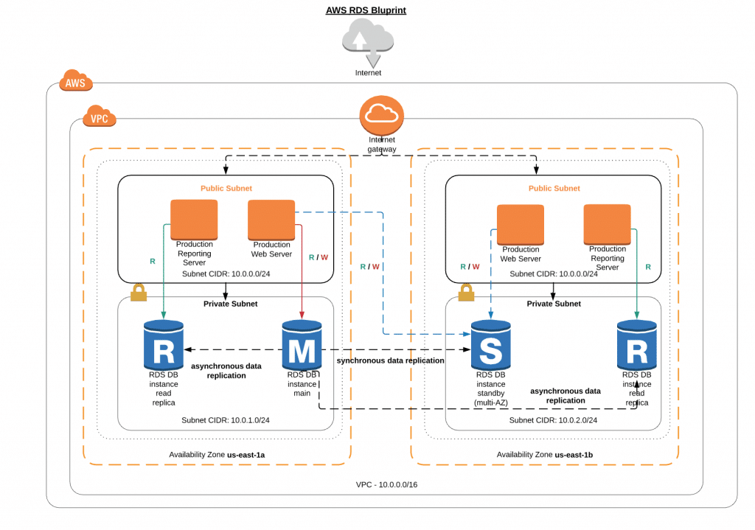
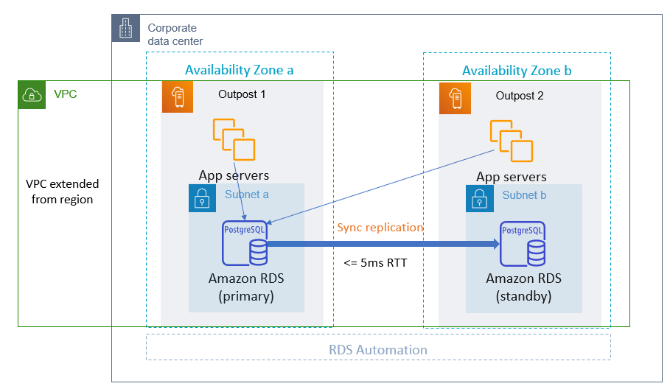
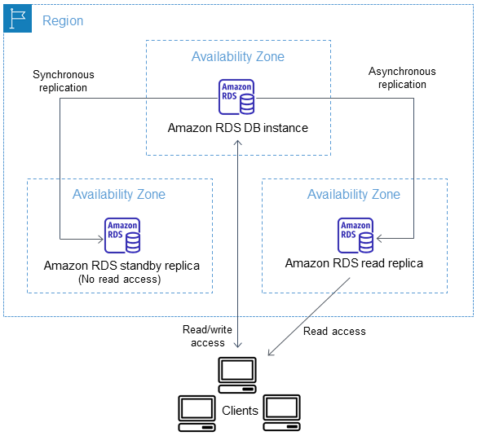
4

What is Amazon RDS?
Amazon RDS is a fully managed database service provided by Amazon Web Services that makes it easy to set up, operate, and scale relational databases in the cloud.
👉 In simple words:
You focus on using the database, AWS handles installation, backups, patching, security, and scaling.

🔹 Databases Supported by Amazon RDS
Amazon RDS supports popular relational databases:
Database Engine | Description
MySQL | Popular open-source DB for web apps
PostgreSQL | Advanced open-source DB
MariaDB | MySQL-compatible DB
Oracle Database | Enterprise-grade DB
Microsoft SQL Server | Microsoft ecosystem DB
Amazon Aurora | AWS high-performance DB (MySQL & PostgreSQL compatible)

🔹 How Amazon RDS Works (Simple Flow)
- You create a DB instance
- Choose:
  - Database engine (MySQL, PostgreSQL, etc.)
  - Instance size (CPU, RAM)
  - Storage type
- AWS automatically:
  - Installs DB software
  - Manages OS & DB patches
  - Takes backups
  - Monitors health
- You connect your application using:
  - Endpoint
  - Username & Password

🔹 Key Components of RDS

1️⃣ DB Instance
- A running database server
- Has CPU, RAM, storage, and endpoint

2️⃣ Storage
- General Purpose (gp3/gp2) – normal workloads
- Provisioned IOPS (io1/io2) – high performance DBs

3️⃣ Endpoint
- DNS name used by applications to connect
(Example: mydb.xxxxxx.ap-south-1.rds.amazonaws.com)

🔹 High Availability – Multi-AZ

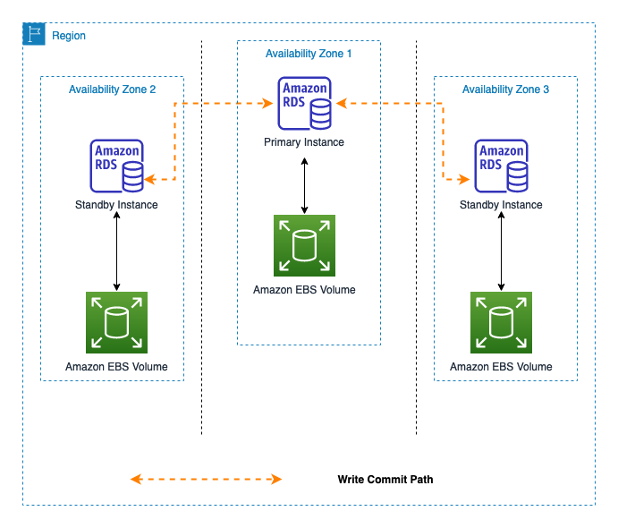

What is Multi-AZ?
- Primary DB in one Availability Zone
- Standby DB in another AZ
- Automatic failover if primary fails
✅ Benefits
- High availability
- Disaster recovery
- No manual intervention

🔹 Read Replicas (For Performance)

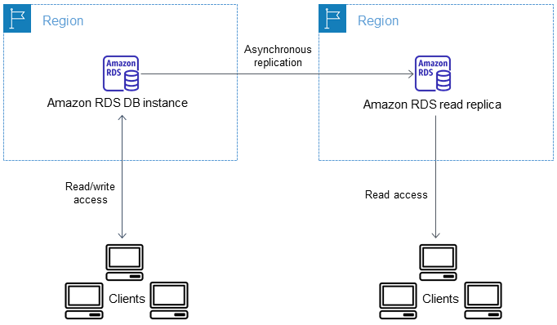

What are Read Replicas?
- Copies of your main database
- Used for read-heavy workloads
📌 Example:
- Main DB → Writes
- Read Replica → Reports, analytics

🔹 Backup & Recovery

Automated Backups
- Enabled by default
- Retention: 1–35 days
- Point-in-Time Recovery

Manual Snapshots
- User-initiated
- Stored until deleted
- Useful before upgrades

🔹 Security in Amazon RDS

🔐 Network Security
- Runs inside Amazon VPC
- Controlled using Security Groups

🔐 Encryption
- At Rest → AWS KMS
- In Transit → SSL/TLS

🔐 Authentication
- DB username/password
- IAM Authentication (for MySQL & PostgreSQL)

🔹 Monitoring & Performance

Tools Used
- Amazon CloudWatch
- Performance Insights
- Enhanced Monitoring
You can track:
- CPU usage
- Memory
- Disk I/O
- Connections

🔹 Scaling in RDS

Vertical Scaling
- Increase instance size (CPU/RAM)

Storage Scaling
- Increase storage without downtime (most cases)

Read Scaling
- Add Read Replicas

🔹 Pricing Model (Pay As You Go)
You pay for:
- DB instance hours
- Storage used
- I/O operations
- Backup storage (beyond free limit)
- Data transfer
💡 No upfront cost (unless Reserved Instances)

✅ Benefits of Amazon RDS

🌟 Major Advantages
- No server management
- Automatic backups
- High availability (Multi-AZ)
- Easy scaling
- Strong security
- Monitoring & alerts
- Cost-effective for production workloads

❌ Limitations of RDS
- Limited OS-level access (no root)
- Not ideal for non-relational data
- Some advanced DB features may be restricted

🔹 RDS vs EC2 Database (Quick Comparison)
Feature | RDS | EC2
Setup | Easy | Manual
Backup | Automatic | Manual
Scaling | Simple | Complex
Maintenance | AWS | You
Root Access | ❌ | ✅

🧠 When Should You Use Amazon RDS?
✔ Web applications
✔ Enterprise applications
✔ ERP / CRM systems
✔ Production databases
✔ When you want less operational overhead

